**National University of Computer and Emerging Sciences**



Laboratory Manual

for

Programming Fundamentals

| Course Instructor | Sir Aftab Alam |
| --- | --- |
| Lab Instructor(s) | Mr. Shahzaib Khan  Miss. Huda |
| Section | 1N |
| Date | 1st-January-2022 |
| Semester | Fall 2021 |

**Department of Computer Science**

FAST-NU, Lahore, Pakistan

**Objectives:**

* Practice 2D array
* Practice of Functions

**Problem**

1. Implement a cat and mouse game. Create a 5x5 2D matrix. Place 1 mouse randomly in it at start e.g; generate a random number for row and a random number for column placing mouse. The cat starts from [5,0]. When the user presses ‘u’, the cat should move up in the matrix and when user presses ‘r’, the cat should move right. Similarly when user presses ‘d’ move one column down and it should move left when user presses ‘l’. If a cat reaches a cell where a mouse is placed. Show the user that he won.. If user takes more than 10 attempts, show a message that attempts are over.

**Sample output at start of the game:**

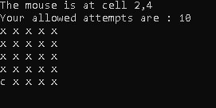

**Sample output when user takes a move:**

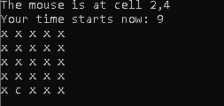

**Sample output when user wins:**

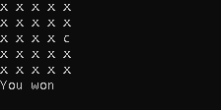

**Sample output when game is over:**

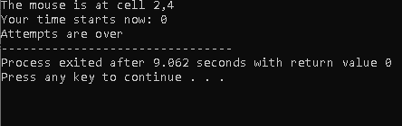

1. Create a simple guessing a number game in which the system will generate a random number and the user will have to guess the number. If the user guess will be greater than the number, the system must shows the user a hint and if the number generated is lesser than user’s guessed number then the system must print” The number is lesser”. User will have 3 chances hence three hints if in three hints, he fails in guessing, show him that game is over otherwise show him that he wins.

**For design and implementation of both games, make proper functions.**